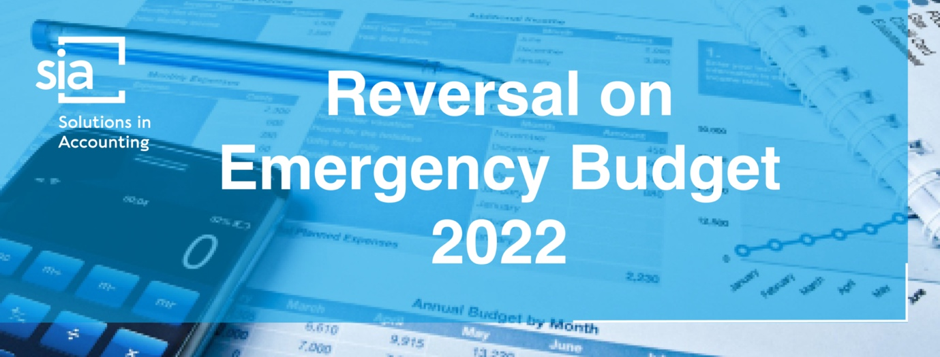

Chancellor brings forward further medium-term fiscal plan measures
As the saying goes, a week is a long time in politics. However, recent events have been unprecedented. At the Mini Budget a new Prime Minister and Chancellor launched a new agenda, ‘The Growth Plan’.
Three weeks later, after huge turmoil, a reversal of most of the elements of that plan and a new statement planned for 31 October. This is now being referred to as the Medium-Term Fiscal Plan, where the Chancellor will publish the government’s fiscal rules alongside an Office for Budget Responsibility forecast, together with what are described as ‘further measures’.
The changes outlined on 17 October are designed to ensure the UK’s economic stability and provide confidence in the government’s commitment to fiscal discipline. Below, we have outlined the current position.

National Insurance contributions
In September 2021 the government published its proposals for new investment in health and social care in England. The proposals were intended to lead to a permanent increase in spending not only in England but also by the devolved governments. To fund the investment the government introduced a UK-wide 1.25% Health and Social Care Levy based on the National Insurance contributions (NICs) system but ringfenced for health and social care.
The Health and Social Care Levy Act provided for a temporary 1.25% increase to both the main and additional rates of Class 1, Class 1A, Class 1B and Class 4 NICs for 2022/23. From April 2023 onwards, the NIC rates were intended to revert back to 2021/22 levels and be replaced by a new 1.25% Health and Social Care Levy.
However, the government has confirmed that it will:
- reverse the temporary increase in NICs from November and
- cancel the Health and Social Care Levy completely.

Comment
According to the government, not proceeding with the Levy will reduce tax for 920,000 businesses by nearly £10,000 on average next year.
For SMEs, the government predicts that the savings will be around £4,200 on average for small businesses and £21,700 for medium sized firms from 2023/24.
In addition, it will help almost 28 million people across the UK save £330 on average in 2023/24, with an additional saving of around £135 on average this year.

More detail for employees and employers
The changes take effect for payments of earnings made on or after 6 November 2022, so:
- primary Class 1 NICs (employees) will generally reduce from 13.25% to 12% and 3.25% to 2% and
- secondary Class 1 NICs (employers) will reduce from 15.05% to 13.8%.
The effect on Class 1A (payable by employers on taxable benefits in kind) and Class 1B (payable by employers on PAYE Settlement Agreements) NICs will effectively be averaged over the 2022/23 tax year, so that the rate will generally be 14.53%.

Comment
The government hopes that most employees will receive the NICs reduction directly via the payroll in their November pay but acknowledges that some will have to wait until December or January, depending on the complexity of their employer’s payroll software.

More detail for the self-employed
Following the principle detailed above, the changes to Class 4 NICs will again be averaged across 2022/23, so that the rates will be 9.73% and 2.73%.

Income tax

Income tax rates
The government had previously announced that there would be a cut in the basic rate of income tax, from 20% to 19%, from April 2024. This was to be accelerated so that it took effect from April 2023. However, whilst the government aims to proceed with the cut in due course, this will only take place when economic conditions allow and a change is affordable. The basic rate of income tax will therefore remain at 20% indefinitely.
At the Mini Budget on 23 September the government announced a plan to abolish the 45% additional rate of income tax from April 2023. However, it was announced on 3 October that the government would not proceed with the abolition of the 45p tax rate.

Dividends
The government has also confirmed that, from April 2023, the 1.25% proposed reduction in rates of taxation will not proceed, meaning that the rates will stay as follows:
- the dividend ordinary rate - 8.75%
- the dividend upper rate - 33.75%
- the dividend additional rate - 39.35%.
As corporation tax due on directors’ overdrawn loan accounts is paid at the dividend upper rate, this will also remain at 33.75%.
These changes will apply in Scotland and Wales as the rules on dividends apply to the whole of the UK.

Business

Corporation tax rates
It had been previously announced that the expected increase in the rate of corporation tax for many companies from April 2023 to 25% would not go ahead. However the government announced on 14 October that this increase will now proceed.
This means that, from April 2023, the rate will increase to 25% for companies with profits over £250,000. The 19% rate will become a small profits rate payable by companies with profits of £50,000 or less. Companies with profits between £50,001 and £250,000 will pay tax at the main rate reduced by a marginal relief, providing a gradual increase in the effective corporation tax rate.

Capital allowances
The Annual Investment Allowance (AIA) gives a 100% write-off on certain types of plant and machinery up to certain financial limits per 12-month period. The limit has been £1 million for some time but was scheduled to reduce to £200,000 from April 2023. The government has announced that the temporary £1 million level of the AIA will become permanent and the proposed reduction will not occur.
Up to 31 March 2023, companies investing in qualifying new plant and machinery are able to benefit from capital allowances, generally referred to as ‘super-deductions’. These reliefs are not available for unincorporated businesses. Interestingly, these allowances were not mentioned in any statement, other than minor amendments to the current rules, so it appears the scheduled withdrawal of them will occur in 2023.

Comment
Businesses incurring expenditure on plant and machinery should carefully consider the timing of their acquisitions to optimise their cashflow.

Seed Enterprise Investment Scheme
From April 2023, companies will be able to raise up to £250,000 of Seed Enterprise Investment Scheme (SEIS) investment, a two-thirds increase. To enable more companies to use SEIS, the gross asset limit will be increased to £350,000 and the age limit from two to three years. To support these increases, the annual investor limit will be doubled to £200,000.

Company Share Option Plan
From April 2023, qualifying companies will be able to issue up to £60,000 of Company Share Option Plan (CSOP) options to employees, twice the current £30,000 limit. The ‘worth having’ restriction on share classes within CSOP will be eased, better aligning the scheme rules with the rules in the Enterprise Management Incentive scheme and widening access to CSOP for growth companies.

Stamp Duty Land Tax
A number of changes are made to the Stamp Duty Land Tax (SDLT) regime. Generally, the changes increase the amount that a purchaser can pay for residential property before they become liable for SDLT.
The residential nil rate tax threshold is increased from £125,000 to £250,000.
The nil rate threshold for First Time Buyers’ Relief is increased from £300,000 to £425,000 and the maximum amount that an individual can pay while remaining eligible for First Time Buyers’ Relief is increased to £625,000.
The changes apply to transactions with effective dates on and after 23 September 2022 in England and Northern Ireland. These changes do not apply to Scotland or Wales which operate their own land transactions taxes.
There are no changes in relation to purchases of non-residential property.

Residential  Band £ | Rate  % | Non-residential  Band £ | Rate  %
0 - 250,000 | 0 | 0 - 150,000 | 0
250,001 - 925,000 | 5 | 150,001 - 250,000 | 2
925,001 - 1,500,000 | 10 | Over 250,000 | 5
Over 1,500,000 | 12
Higher rates may be payable where further residential properties are acquired.

Land Transaction Tax
The Welsh government has also altered its rates in relation to land and buildings in Wales for transactions with an effective date on or after 10 October 2022.

Residential  Band £ | Rate  % | Non-residential  Band £ | Rate  %
0 - 225,000 | 0 | 0 - 225,000 | 0
225,001 - 400,000 | 6 | 225,001 - 250,000 | 1
400,001 - 750,000 | 7.5 | 250,001 - 1,000,000 | 5
750,001 - 1,500,000 | 10 | Over 1,000,000 | 6
Over 1,500,000 | 12
Higher rates may be payable where further residential properties are acquired.

IR35 and off-payrolling
Over the last 20 years, there have been numerous changes to the tax system to try and address ‘disguised employment’ and to generate additional tax and NICs accordingly. In a surprise announcement, the government had stated that it would repeal the off-payroll working rules from 6 April 2023. However, it has been confirmed that this change will not go ahead and the off-payrolling rules will remain in force.

VAT-free shopping areas
The government had announced that it would introduce a modern, digital, VAT-free shopping scheme with the aim of providing a boost to the high street and creating jobs in the retail and tourism sectors. However, this change will not go ahead either.

Alcohol duties
The government had announced that it would freeze alcohol duty rates from 1 February 2023 but this will not go ahead.

Energy bills
The government has announced unprecedented support to protect households and businesses from high energy prices. The Energy Price Guarantee and the Energy Bill Relief Scheme are supporting millions of households and businesses with rising energy costs and the government has stated that these schemes will continue to do so from now until April next year.
However, the government states ‘that it would be irresponsible…to continue exposing the public finances to unlimited volatility in international gas prices’.
Consequently, a Treasury-led review will be launched to consider how to support households and businesses with energy bills after April 2023. The aim is to design a new approach that will cost the taxpayer significantly less than planned whilst ensuring enough support for those in need. The government has also stated that any support for businesses will be targeted to those most affected and that the new approach will better incentivise energy efficiency.
However, this is not the end of the story. Government departments will be asked to find efficiencies within their budgets and the Chancellor is expected to announce further changes to fiscal policy on 31 October to put the public finances on a sustainable footing.

